“How should history remember Thomas Jefferson?”

Introduction

This lesson plan is a focused inquiry, suitable for students in an 8th Grade U.S. Studies Course, or a High School Government class. The instructional methodology (Empathy Mapping) can be used to deconstruct other historical figures as well.

The inquiry walks students through the process of extracting qualitative data from multiple written sources, and organizing the information into a template that allows for intertextual analysis (Ohio RSIT 9).

As in any inquiry, the lesson culminates in students constructing an argument in response to the compelling question.

Opening

Students will complete a journaling exercise in response to the prompt:

“If someone asked you to describe another person, what kind of evidence would you collect to create a full picture of that person?”

If students have access to an online discussion forum, you can open this question up as a discussion topic within the forum.

What is an Empathy Map? (Pg 1 of Student Text)

Empathy Maps are a tool used by designers to better understand what motivates a person. Say, for example, you were about to open a new television store. Before you sit down to design the store and write the employee manual, you may want to get a better picture of your potential customer. Most people can’t simply tell you what they want, so we look instead at what they can tell us to draw inferences.
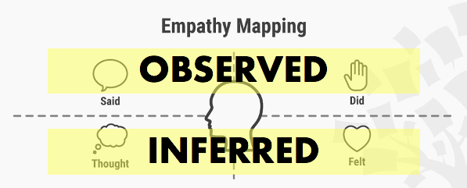
The empathy map provides a place to organize the information we collect, which enables us to draw conclusions about the person at the center for the map.

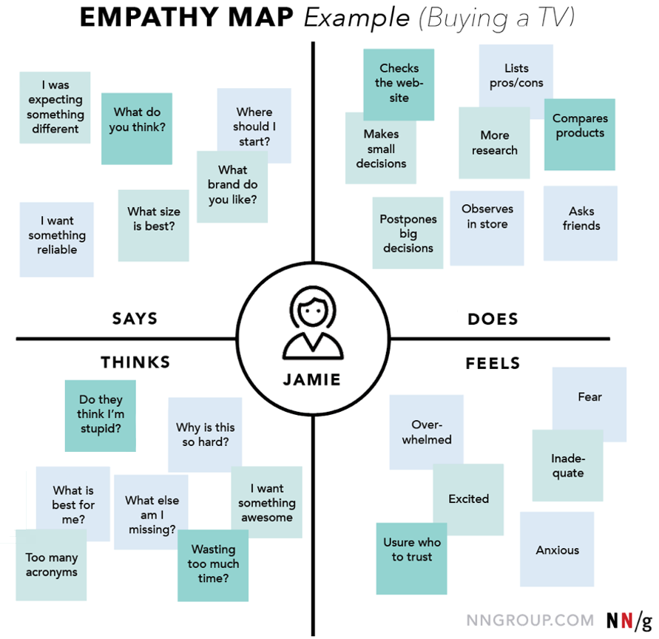

The designer uses their observations of what the customer says and does to make inferences (educated guesses) about what the customer thinks and feels.

Although this is not a complete picture of the consumer, it does provide a window into her motivations and helps the designer make decisions that will make their consumers happier. The goal is that, by observing even more customers, the designer will create a store where the customer leaves satisfied with the experience and their purchase, making it more likely they will recommend to friends and come back to buy again.

Our job isn’t to design a new electronics store (although that may someday be your goal) but as students we can steal from the design world to better understand historical figures. The Founders, for example, are shrouded in a lot of mystery and myth. The stories we tell about people who lived two-hundred years ago have evolved over time, making it harder to create a clear picture of who they were. And, like all of us, they’re complicated! We need to find a way to organize all of the data available on a historical figure to help us understand.

How should we remember Thomas Jefferson?

In this focused inquiry, students will consider the legacy of Thomas Jefferson in regard to slavery. By taking this narrower slice of the historical legacy of one of our founders, students have a focused lens to consider several texts, both primary and secondary. The inquiry also provides students with an opportunity to practice the skill of drawing inferences, supported by evidence, to fill in the gaps that exist in any historical analysis.

Document Analysis

Students will review excerpts of six primary and secondary sources to draw conclusions and make inferences about what Thomas Jefferson said, did, thought, and felt about the institution of Slavery in the United States.

Students should read each text, looking up any unfamiliar words. After reading, students should look for quotes, or create summaries of the text, which can be organized into one of the four boxes of the empathy map. For each text, an introductory paragraph sets context and aids in understanding.

Source List
- Deleted clause of the Declaration of Independence (written by Thomas Jefferson)
- Draft version of the Land Ordinance of 1784 (written by Thomas Jefferson)
- Roll of Negroes November 1794 (Records of Jefferson’s plantation Monticello)
- Statement on the Paternity of Sally Hemmings’ Children (authored by the Thomas Jefferson Foundation)
- Notes on the State of Virginia Query XVIII: Manners (written by Thomas Jefferson)
- Thomas Jefferson’s Will (drafted by Thomas Jefferson)

Summary Assessment

Students should construct an argument that answers the compelling question “How should we remember Thomas Jefferson?” The argument needs to include at least one claim, supported by evidence. Evidence can be drawn from the sources in the inquiry, and any additional sources students have studied or discover during their exploration.

Sample Empathy Map

Student responses may include some of the following observations.
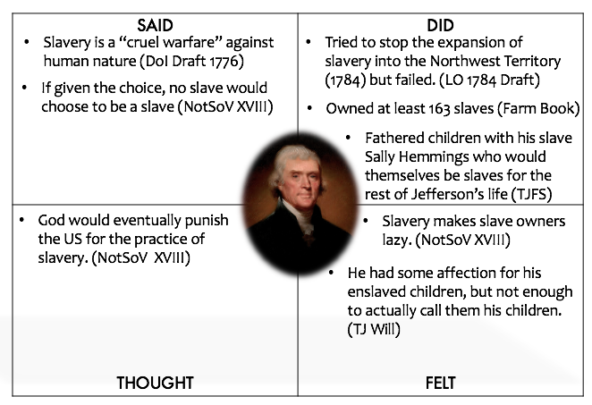

The pages that follow are student text.

Student Text: What is Empathy Mapping

Empathy Maps are a tool used by designers to better understand what motivates a person. Say, for example, you were about to open a new television store. Before you sit down to design the store and write the employee manual, you may want to get a better picture of your potential customer.

The empathy map provides a place to organize the information we collect, which enables us to draw conclusions about the person at the center for the map. The designer uses their observations of what the customer says and does to make inferences (educated guesses) about what the customer thinks and feels.

Although this is not a complete picture of the consumer, it does provide a window into her motivations and helps the designer make decisions that will make their consumers happier. The goal is that, by observing even more customers, the designer will create a store where the customer is happy, making it more likely they will come back to buy again.

Our job isn’t to design a new electronics store (although that may someday be your goal) but as students we can steal from the design world to better understand historical figures. The Founders, for example, are shrouded in a lot of mystery and myth. The stories we tell about people who lived two-hundred years ago have evolved over time, making it harder to create a clear picture of who they were. And, like all of us, they’re complicated! We need to find a way to organize all of the data available on a historical figure to help us understand.
Source A: Deleted Clause from the Declaration of Independence

Thomas Jefferson was the primary author of what would become the Declaration of Independence. The final version, however, would differ somewhat from his earlier drafts. The excerpt below is of a portion relating to slavery that was not included in the finished document. It was intended to be included in the portion listing the complaints against the King.

“…he has waged cruel war against human nature itself, violating its most sacred rights of life & liberty in the persons of a distant people who never offended him, captivating & carrying them into slavery in another hemisphere, or to incur miserable death in their transportation thither. This piratical warfare, the opprobrium of infidel powers, is the warfare of the Christian king of Great Britain; determined to keep open a market where MEN should be bought & sold…”

Source B: Draft of the Land Ordinance of 1784

The Confederation Congress (the legislature that existed prior to the Constitution under the Articles of Confederation), had the job of deciding how to govern the land that would eventually be called the Northwest Territory. Thomas Jefferson submitted the draft language below, which ultimately was not agreed to by the Congress and was not passed.

“Provided that both the temporary and permanent Governments be established on these principles as their basis…5. That after the year 1800 of the Christian era, there shall be neither slavery nor involuntary servitude in any of the said States, otherwise than in punishment of crimes, whereof the party shall have been duly convicted to have been personally guilty.”

Source C: Roll of Negroes Nov, 1794
Jefferson kept detailed records for his plantation Monticello. The excerpt below is one page of this record from November 1794, listing the names and family relationships of 163 slaves.
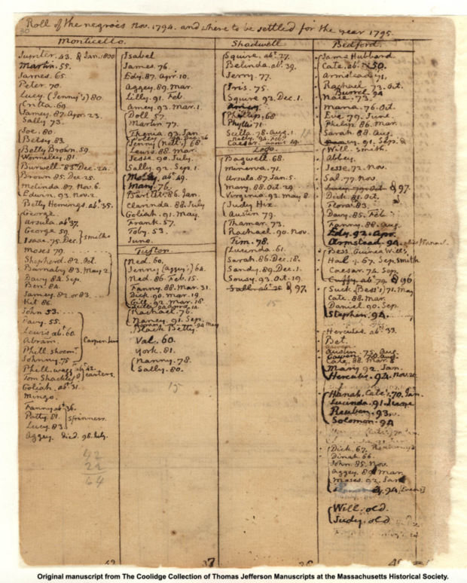
Source D: Paternity of Sally Hemings’s Children

Scholars at the Thomas Jefferson Foundation conducted an extensive DNA analysis of several known descendants of the slave Sally Hemings and known descendants of Thomas Jefferson. The results of their study are described below.

“The issue of Jefferson’s paternity has been the subject of controversy for at least two centuries, ranging from contemporary newspaper articles in 1802 (when Jefferson was President) to scholarly debate well into the 1990s. It is now the Thomas Jefferson Foundation’s view that the issue is a settled historical matter.
A considerable body of evidence stretching from 1802 to 1873 (and beyond) describes Thomas Jefferson as the father of Sally Hemings’s children. It was corroborated by the findings of the Y-chromosome haplotype DNA study conducted by Dr. Eugene Foster and published in the scientific journal Nature in November 1998. The DNA study did prove paternity of a Jefferson family member and corroborated the ample documentary and oral history evidence. Other evidence supports Thomas Jefferson’s paternity as well, including his presence at Monticello during Sally Hemings’s likely windows of conception, the names of Hemings’s surviving children, and the fact that all of her children were granted freedom – they were either allowed to leave the plantation, or legally emancipated in Jefferson’s will, a unique occurrence among Monticello’s enslaved families.”
Source E: Notes on the State of Virginia, Query XVIII: Manners

Although Thomas Jefferson was the writer of a great number of important documents, letters, and legal papers throughout his life, he only ever authored a single full-length book: Notes on the State of Virginia. The excerpt below is from a section of this book dealing with manners.

“For if a slave can have a country in this world, it must be any other in preference to that in which he is born to live and labour for another: in which he must lock up the faculties of his nature, contribute as far as depends on his individual endeavours to the evanishment of the human race, or entail his own miserable condition on the endless generations proceeding from him. With the morals of the people, their industry also is destroyed. For in a warm climate, no man will labour for himself who can make another labour for him. This is so true, that of the proprietors of slaves a very small proportion indeed are ever seen to labour. And can the liberties of a nation be thought secure when we have removed their only firm basis, a conviction in the minds of the people that these liberties are of the gift of God? That they are not to be violated but with his wrath? Indeed I tremble for my country when I reflect that God is just: that his justice cannot sleep for ever: that considering numbers, nature and natural means only, a revolution of the wheel of fortune, an exchange of situation, is among possible events: that it may become probable by supernatural interference! The Almighty has no attribute which can take side with us in such a contest.”
Source F: The Will of Thomas Jefferson

Prior to his death, Thomas Jefferson wrote a “Last Will and Testament,” which described what he wanted to happen to all of his property after he died. As slaves were property, it was necessary that he also made provisions for what would happen to his slaves. Of the slaves that remained upon his death, only a few received particular mention in his will. The hyperlinks for each of the men’s names below links to more detailed profiles about them at the Thomas Jefferson Foundation.

“I give to my good, affectionate, and faithful servant Burwell his freedom, and the sum of three hundred Dollars to buy necessaries to commence his trade of painter and glazier, or to use otherwise as he pleases. I give also to my good servants John Hemings and Joe Fosset their freedom at the end of one year after my death: and to each of them respectively all the tools of their respective shops or callings: and it is my will that a comfortable log house be built for each of the three servants so emancipated on some part of my lands convenient to them with respect to the residence of their wives, and to Charlottesville and the University, where they will be mostly employed, and reasonably convenient also to the interests of the proprietor of the lands; of which houses I give the use of one, with a curtilage of an acre to each, during his life or personal occupation thereof.”

Additional Considerations
- The will mentions that each of these men have wives, but they are not freed. What would that mean for any children they might have (or already have)?
- Why were these three men (along with two others) given special treatment?

Empathy Mapping Thomas Jefferson

After reading each of the six sources, use the Empathy Map below to draw conclusions about Thomas Jefferson’ relationship to the practice of slavery in the United States. Be sure to indicate the source you used to draw your conclusion. We have given you one sample conclusion to help you get started.

SAID  Slavery was a “Cruel warfare” against human nature (Dec. of Ind.) | DID
THOUGHT | FELT

Answering the Question: How Should We Remember Thomas Jefferson

Like all people, Thomas Jefferson is a complicated man. What should we consider to be his legacy as to the practice of Slavery in the United States? Use the space below to construct an argument (claim + evidence) to how you believe we should remember him. You can use information from any of the six sources, and any additional information you find.

